Spring Core - Incorporate Logging
Added logging properties in the application.properties file
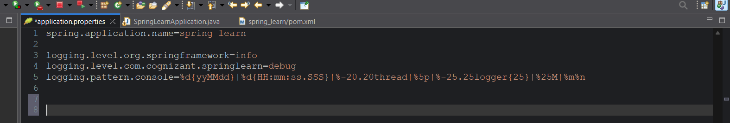
Added start, debug and end logger info
